MIS 443 – BUSINESS DATA MANAGEMENT
Assignment 4 – Individual PostgreSQL Database Project
School Database
Student Name: Nguyễn Thị Ánh Tuyết
Student ID: 2332300334
Course: MIS 443 – Business Data Management

1. Introduction
The School database is a relational database designed to manage information about students, professors, courses, and enrollments. This project recreates the School database using PostgreSQL and pgAdmin. It demonstrates the creation of tables, relationships, CSV data import, and SQL queries for retrieving and analyzing educational data.
2. Main Tables and Relationships
Table | Description
Students | Stores student information, including names, email, enrollment date, graduation year, and major.
Professors | Stores professor information such as department and hire date.
Courses | Stores course details and the professor responsible for teaching each course.
Enrollments | Records student enrollments, semester, year, and grades.
Entity Relationship Diagram (ERD)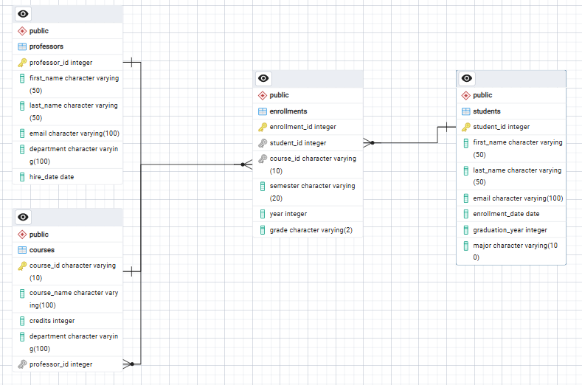

3. Database Implementation
The database was implemented using PostgreSQL and pgAdmin 4. Four tables were created with primary keys and foreign key relationships. Data was prepared in CSV format and successfully imported into PostgreSQL. SQL queries were tested using the Query Tool in pgAdmin.
4. SQL Questions Summary
A total of 16 SQL practice questions were completed successfully. The queries covered:
- Data filtering
- Sorting
- Aggregate functions
- GROUP BY and HAVING
- Table joins
- NULL handling
5. Selected pgAdmin Screenshots
This section presents selected SQL query results executed in PostgreSQL. The screenshots demonstrate that the database was successfully created, populated with data, and queried using SQL statements.
Figure 1. Students Majoring in Computer Science
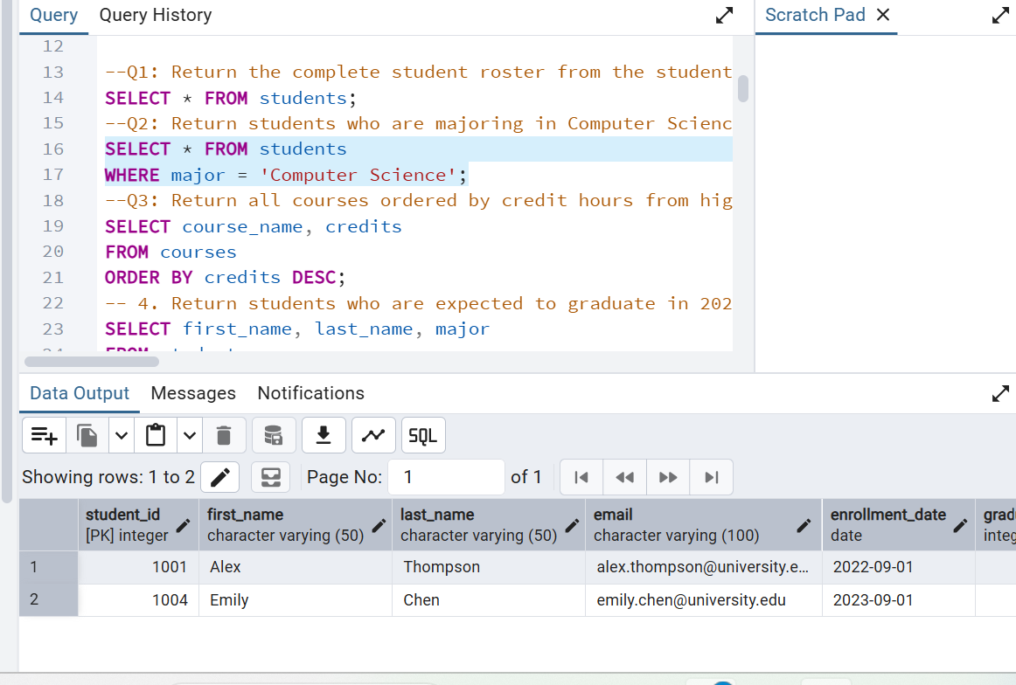
Figure 1 shows the students who are majoring in Computer Science. The query filters student records based on the major field and returns the students' names and graduation year.
Figure 2. Courses Ordered by Credits
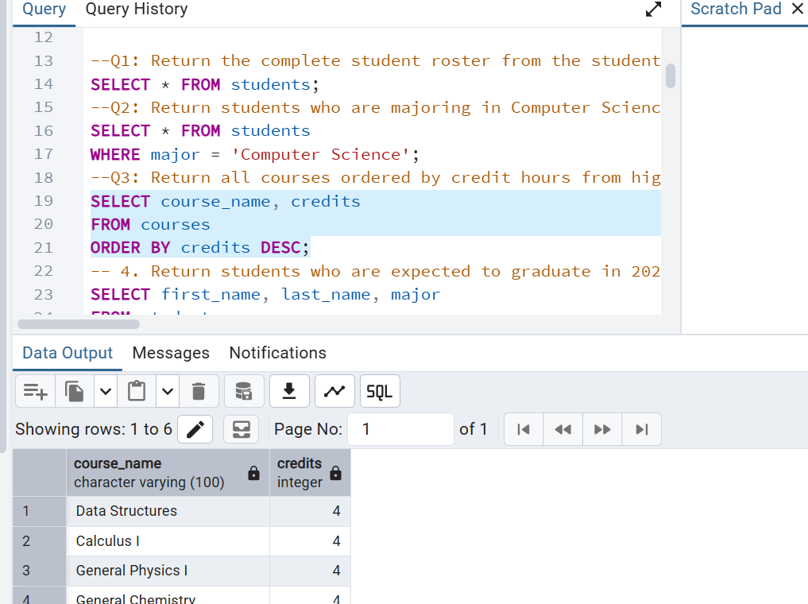
Figure 2 displays all courses sorted by credit hours in descending order. This query demonstrates the use of the ORDER BY clause.
6. Challenges and Solutions
Challenge | Solution
CSV import errors | Corrected the CSV format and enabled the Header option.
NULL values were not imported correctly | Adjusted the CSV data and updated NULL values in PostgreSQL.
COPY permission error | Used pgAdmin Import/Export Data instead of the COPY command.

7. Conclusion
This project provided practical experience in creating and managing a relational database using PostgreSQL. It improved my understanding of database design, relationships, CSV data import, and SQL queries such as filtering, sorting, joins, grouping, and aggregation.
8. GitHub Repository
Repository: https://github.com/tuyetnguyenthianhbbs23-collab/MIS-443

